NOTICE OF PUBLIC MEETING OF THE BOARD OF DIRECTORS
FOR THE
AXTELL WATER SUPPLY CORPORATION

Notice is hereby given that a Meeting of the Board of Directors of the Axtell Water Supply Corporation will be held Tuesday, January 16, 2024 at 6:00 p.m. at the Axtell Water Supply Office located at, 207 North 5th Street, Axtell, Texas, at which time the following subjects will be discussed:

- Call to order
- Establishment of a quorum
- Verification of proper posting
- Recognition of guests (comments limited to 3 minutes)
- Update Board on F.H.L.M. Regional W.S.C.
- Discuss/Approve appointment of new Board Member
- Discuss/Approve Paul Pina water easement
- Discuss/Approve adjustments to Johnny Childre’s pay scale
- Discuss/Approve bids on well pipe and pumps
- Discuss/Approve the minutes of the December 12, 2023 meeting
- Discuss/Approve Accounts Payable
- Executive session to deliberate the appointment, employment, evaluation,
reassignment, duties, discipline or dismissal of a public officer or employee. Section 551.074 Open Meetings Act
13. Adjournment

Posted January 11, 2024

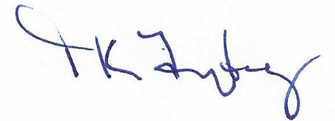
Tricia K. Freytag
Manager/Operator
Axtell Water Supply Corporation

